SimpleWordprint3.x
(June 25, 2013 4:45p.m.)

Getting Started
Download the SimpleWordprint3.x program and run it by double clicking the .exe file. When you open the program, you will see a small window on your screen. (These screen shots are examples from earlier versions of SimpleWordprint, but are similar to the latest version.)

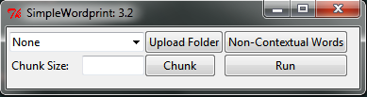

Note: Keep in mind, the screen shots will look different depending on your Operating System

Overview
There are four main steps to performing an analysis. They are: Prepare Documents, Run Program, Check Word List, Save Results.
The following flow chart shows these steps with a little more detail. Each of these steps will be explained after the flow chart.
After the explanations is an Appendix with additional information. This is followed by a Detail Appendix with more documentation about the program and its functioning.

Flow Chart for Using SimpleWordprint

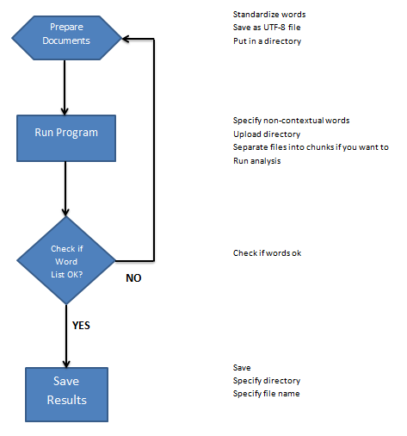

Prepare Documents
Before you begin using the program, you must prepare the documents you want analyzed.
To prepare the documents, you must first edit them to your specifications.
- Open your documents in a program that has a spell check feature to make sure your words are correctly spelled.
- If you don’t want headings or signatures counted in your word count, make sure you delete them.
- If there are words you would like to standardize, this is the time to do that (ie. can’t cannot).
Once you have edited your documents to the correct specifications for your project, you will want to save them as plain .txt files. (Do not have commas in your file names.)
Once you have selected “Save As”, you will see this screen pop up. You will want to save as type “Plain Text”.
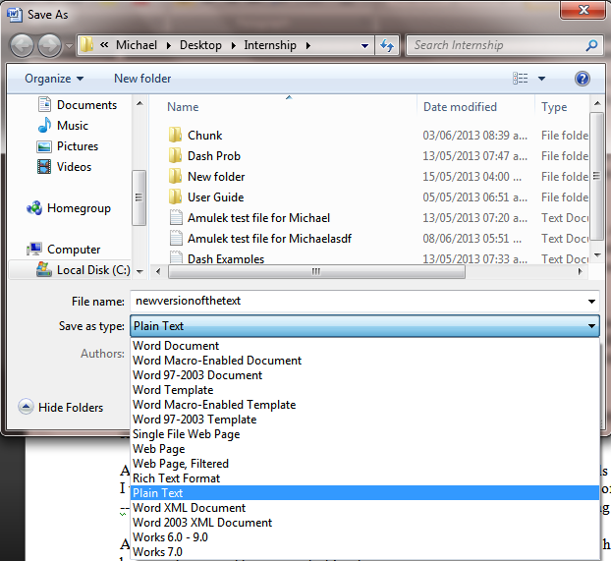

Once you have selected “Plain Text”, click “Save”. Once you have selected the “Save” button, a new window will appear. You will want to select the “Other encoding” option. You will then be able to choose “Unicode (UTF-8)”. You will want to select this option so the program will run correctly. After selecting it, select “OK”.

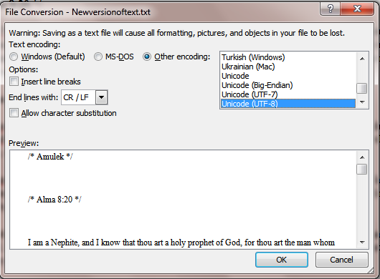

You should create a sub-directory in the main directory with your files. This directory will include all of the UTF-8 files that you have created. Then, you will be able to select this directory to load into the program.
You are now ready to run the program.

Run the Program
Once you have completed the above steps, you are now ready to use the program. You will need to locate the .exe program file and launch it. When you launch the program, the first window you will see is:

If you want to count non-contextual words separately, you will first insert them by clicking on “Non-Contextual Words.” You will then see this:
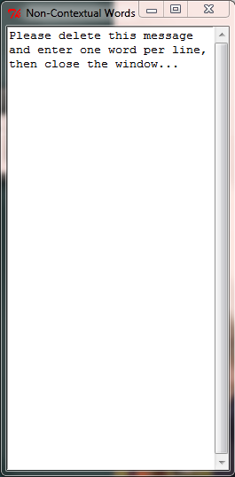
You will then delete the message in the window and insert your non-contextual words, one word per line. If you already have a predetermined list of non-contextual words, you may copy and paste them into the window. You can use ctrl-C and ctrl-V to copy and paste, respectively. When finished, exit the window by clicking the red X in its upper right. (The words will be saved automatically.)
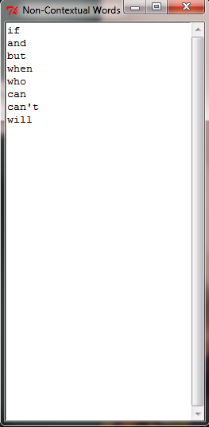

You are now ready to load your UTF-8 Files. Click the “Upload Folder” button. You will then see a pop-up window:
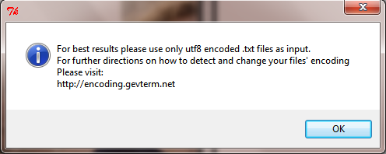
Click “Ok”. You will then see this window, allowing you to choose the directory to upload:
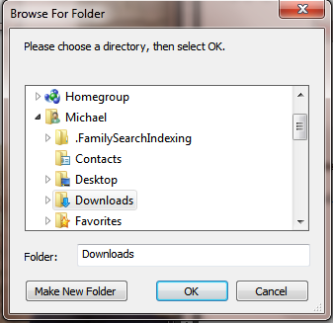

Select your directory and click “Ok”.
After clicking “OK”, “All_Files” should appear in the initial window. If you click on the arrow, it will give you the option of selecting one of the files if you just want to run the program with one file instead of the whole directory.

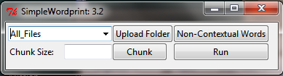

Chunking
“Chunking” is having the ability to divide your file(s) into chunks. A chunk is just a set of words. You can specify how many words you would like in a chunk. For example, if you insert “500”, the program will divide the files into sections of approximately 500 words a section. (For more information, see the algorithm in the detail appendix.)
So, you either have the option of Chunking or running the program without chunking. To chunk, you will want to type in the number of words in the Chunk Size box on the main screen, then press “Chunk”. The program will separate your files into chunks and save them in a subdirectory of the uploaded directory. Then the program will load that subdirectory to be ready for analysis.
Running the Analysis.
After selecting an individual file or the “All_Files” option, click “Run”. Depending on the size of your file(s), the time it takes to analyze everything will vary. After a short time, depending on the size of your file(s), the results should appear:
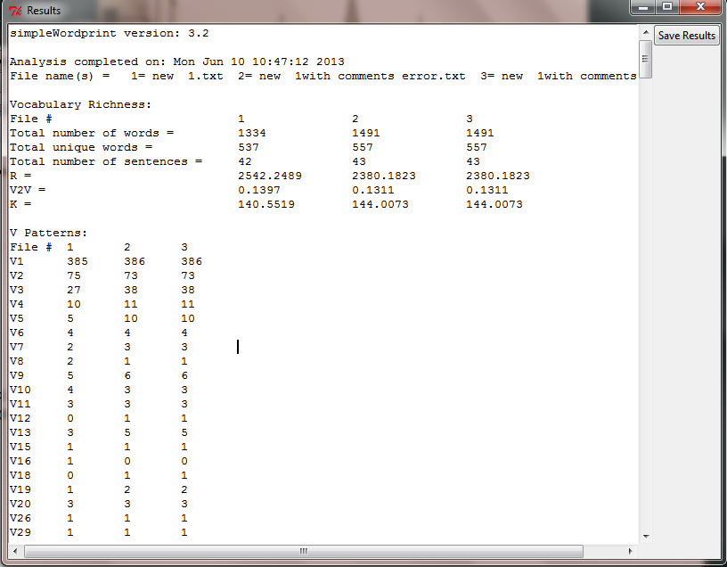

Results
After running the program to sort out everything, you will see one column for each uploaded file and various numbers and letters in the results screen. The following is a list of the abbreviations and numbers with a brief explanation.
Vocabulary Richness
- File #- The file number is a number that the program designates to a file. For example, if you have more than one file, each file will be numbered.
- Total number of words- This number indicates how many words were found in your files. This number includes all words, with repeats counted.
- Total unique words- This indicates how many different words were used in the file. i.e. repeats are not counted.
- Total number of sentences- This number indicates how many sentences were found in the file.
- R, V2/V and K- These are measures of vocabulary richness. (See the Appendix for more information.)
V-Patterns
V(#)- Represents the number of times a word appears in the file. For example:
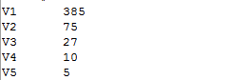
The circled V-pattern says that there are 385 words that appear once and only once in the file. So, the V2 indicates that there are 75 words that appear twice and only twice in the file.

Word Length Frequencies
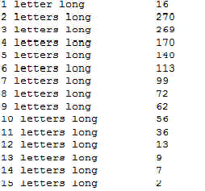
Here we have word length frequencies. The circled example says that there are 56 occurrences of words (including repeats) that are 10 letters long.

Word List in Frequencies
The list that follows the Word Length Frequency is a list of all words of the file and how many times they appear in the file.

Word Pattern Ratios
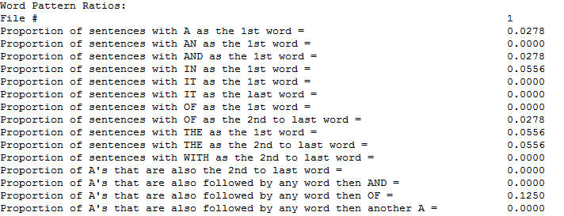
Word pattern ratios show the proportion of sentences of a designated type or the proportion of certain words used in designated ways within sentences.

Non-Contextual Words
Finally, if you made a non-contextual word list at the beginning, a list of the words as well as their frequencies will appear.

Check if Word List OK?
You should look through word list carefully to detect if you actually made all the changes to standardize words that you wanted. If you discover some words that you should have standardized, but did not, then go back to those files that have this word in them and perform the standardization, save as UTF-8 files as before. Be sure to replace the old UTF-8 file with the new one into your directory of UTF-8 files. Then re-upload the directory and run the chunking or analysis again. Continue checking your word list and repeat the above steps until you are satisfied with the words.
Saving the Results
Once you have looked at your results, you will want to save them. To do so, you click on the “Save Results” button in the upper right hand corner of the screen.
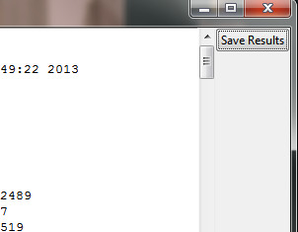
After clicking on the “Save Results” button, you will be given the option to save it in your chosen directory. The default directory will be the directory that is currently uploaded. You can change the name of the file and you can select a different directory. The file is saved as a comma delimited .csv file. Csv files can be easily opened in excel along with many other csv supporting programs. (Note, in the .csv file, instead of saying “5 letters long” this will be designated by “L5” etc.)

Congratulations! You have successfully used Simple WordPrint!

Appendix
Some document preparation notes:
Titles:
If you have a title of a section that you want to leave in the text and count it as a sentence, you will need to either 1). Put a period on the end of it. Or 2). Add a blank line after it. If you do not do one of these things, then the program will not recognize it as a separate sentence and it will be joined with the next sentence.

Apostrophes:
Words with apostrophes in them, like “can’t” and “they’ll” will be treated as follows:
For word counts they will appear with the apostrophe and will be counted as is. (Note an exception to this is a word with an apostrophe as the first or last character, then it is deleted.)
But for letter counts, the apostrophe will not be counted. Thus “can’t” is counted as 4 letters long and “they’ll” as 6 letters long.
If you want to change all occurrences of “isn’t” to “is not” then in your document preparation you should use a search and replace for all occurrences of “isn’t”.

Numbers:
Numbers are ignored and not counted at all.
Formula Notes:
R = 100 * Ln(N) / (1-V1/V)
Where: Ln indicates the natural logarithm
N is the total number of words in the file.
V1 is the number of words that occur once and only once in the file.
And V is the number of unique words in the file (repeats are not counted).

V2/V = V2 divided by V
Where: V2 is the number of words that occur twice and only twice in the file.
And V is as before, the number of unique words in the file.

K = 10,000 * (sum(i²*Vi) – N)/N²
Where: Vi is the number of words that occur i times and only i times in the file.
And N is as before, the total number of words in the file.

Detail Appendix
Guiding principles of “stylometry” and of the program:
1). We are trying to identify the thinking style of an author as manifested by his word choices.
2). We are not taking into account spelling, handwriting, abbreviation style, etc. as these do not focus on word choices.
3). We will require the user to spell check and standardize words before using the program. Also recommend to them to document their decisions.
4). Therefore, we do not do spell check for them in the program.
5). Tell them some tips on how to arrange to get correct sentence counts by including periods or a blank line after titles that they want counted as a sentence.
6). The program must be extremely easy to use: All decisions hard wired so no options for user. Also we will not have them do any case by case.
7). The program should batch upload and process.
8). All counts must be correct: sentence, word, word length.
9). Must include word length counts
10). Program outputs a word list with frequencies.
11). When counting up unique words, etc., we leave all apostrophes, which are within words, in. So ain’t is ain’t, can’t is can’t, you’ll is you’ll, etc. But when counting letters, we do not count those apostrophes, i.e. we ignore them. The letter counts would be ain’t = 4, can’t = 4, you’ll = 5.
12). Numbers and any word with a number in it do not count at all.
13). For anything else, like hyphens and ampersands, see the pre-process questions list.
14). For author analyses, the user should have already eliminated quotations of other people (but leave in paraphrases), eliminated titles, dates, and signatures; spell-checked the text to some consistent standard; and saved it as a UTF-8 file.

SimpleWordprint Program Flow

1-START PROGRAM
options: -Upload Folder
-Chunk -> will not do anything unless a folder is uploaded and a chunk size is
indicated
-Non-Contextual Words -> provides a new window in order for the user to input
non-contextual words, one per line
-Run -> Will not do anything until a folder is uploaded

2- UPLOAD FOLDER
User selects a folder which the program scans for .txt files and then uploads them.

3- CHUNK OR RUN

3a- CHUNK
If the user chooses to chunk a file or entire folder they must first indicate a chunk size in the chunk size entry box, it must be a number, if any non digit character is entered in the box, the program will strip it out. So if you entered 4aaaaa4 you would get a chunk size of 44.

Once there is an individual file selected in the selection dropdown menu or All_Files is selected as well as a numerical chunk size indicated in the chunk size entry box, the chunk button may be pressed.

The chunk subroutine will:
1-Create a subfolder to contain the chunks with the chunk size indicated in the folder name
2-Initial preprocessing is done to the file or files
3- Sentences are identified, separated from each other, and stored in an array
4- A word count is determined
5-The chunking algorithm is used and blocks of text are divided into chunks and stored in an array
6- Each chunk is output to a text file with a blank line between each sentence
7- The subfolder containing the chunks of text are uploaded to the program as the active directory for analysis

3b-RUN

Whatever folder is uploaded to the program will be analyzed when the run button is pressed. If the dropdown box indicates all files then every .txt file in the uploaded folder will be analyzed, or an individual file will be analyzed if it is the only one selected.

The run subroutine will: (the program only processes one file at a time, even if all files is selected)
1-Clear all variables of previous runs' content
2-Load the entire text of the current file being analyzed
3-The file is preprocessed
4- The file is split into sentences and stored in an array
5-Word counts and letter counts (Lpatterns) are determined
6- Unique words are determined
7-Word pattern ratios are determined
8-Non-contextual word counts are determined
9-vPatterns are determined
10-R, V2V and K are determined
11-All variables are stored on an array and the next file is processed
12-Once all files are analyzed, the results are printed to temporary files: wordprintTEMP.csv then to output.txt
Both are stored in the current working directory where the program is contained, they will both be deleted when the program closes
13-output.txt is automatically read into a new separate program window for viewing.
14-The results can be saved in csv format to anywhere on the user's computer by clicking the save button in that window, but the default is in the uploaded directory

4- EXIT
The user can return to the initial startup screen to run another folder/file or exit the program

More particulars about the program’s functioning:
1- Unicode characters are "Normalized" to ascii characters (eg PROTOGÉ becomes PROTOGE without the accent.

2- Fancy unicode quotation marks and apostrophes are made into plain ascii " and ' marks. (Note: Do not have other fancy Unicode characters in your file.)

3- Runs of whitespace are collapsed (eg. 'hello there.' goes to
'hello there.')

4- The word "wo" is converted to "woe". NO If you want it converted, then do that in your spell check during document preparation.

5- Contractions are left as they are: 's 'd 'll 've 're 'm n't are not changed, but the apostrophe is not counted during the word length processing.

6- The various possible questions are not asked to the user but have hard wired defaults as follows:
a. let's => let us ? NO let’s remains let’s
b. n't =>not ? NO words like can’t and isn’t remain can’t and isn’t
c. cannot =>can not ? NO left as is, cannot. Remember we are after word choice, not idea choice.
d. 've => have ? NO I’ve remains I’ve
e. 're => are ? NO they’re remains they’re
f. 'm => am ? NO I’m remains I’m
g. 'll => will ? NO they’ll remains they’ll
h. won't => will not ? NO won’t remains won’t
i. shan't => shall not ? NO shan’t remains shan’t
j. 's is expanded case by case ? NO Mark’s remains Mark’s
k. 'd is expanded case by case ? NO I’d remain I’d
l. ain't is expanded case by case ? NO ain’t remains ain’t
m. &c => etc. ? NO This should have been taken care of by spell check. “Etcetera” will be counted as a different word than “etc.”
n. all other & case by case ? NO & is ignored. If you want it to count as “and”, change it during document preparation.
o. all # case by case ? NO ignore them for now. Note: abbreviations like oz. or lbs. are left as abbreviations, and not converted to words.
p. end of line hyphens case by case ? NO the word is contracted, then the hyphen is deleted. See q below.
q. close words with one remaining hyphen (eg. pre-processor becomes preprocessor) ? Yes
r. space out any remaining hyphens (eg. pre-processor becomes pre processor) ? NO it should have been taken care of by p and q or it just deletes the extra hyphens.
s. handle any remaining hyphens case by case....(the program is expecting you to only type the replacement for the hyphen, not the whole phrase (eg. if you typed as replacement "preprocessor" for pre-processor it would end up prepreprocessorprocessor.)) ? NO it should have been taken care of by p and q. A dash by itself, i.e. surrounded by spaces, is ignored when counting words and letters.
t. Any other strange symbols, like math symbols, =, <, >, /, etc., or other weird things, just ignore ? Yes

7- After splitting the file up into sentences the program makes all letters lower case. Which is nice since, otherwise, Example would not be the same as example in the word counts.

8- Ignores any numeric expression of any kind using digits. Any word containing any digit 0-9 is also ignored.

9- All punctuation is left in.

10- The stem() method from disinfect.pm is NOT used:
The stemming method is NOT used to regularize all words in the English language with the goal to get all words to reflect their root. It would remove any kind of conjugation including king james style inflections, past tense like ed, gerunds like ing, plural forms, adjective forms like -est and -er, it would also remove word final -e where possible, rate would not go to rat however but procreate would become procreat, word final -i becomes -y, and word final y =>ie in monosyllabic -i stems. We want the words, not the roots. Other items should have been dealt with in your spell check.

The sentences are being recognized in five steps:

1- All possible sentences are marked with an end of sentence (EOS) marker
a- This includes lines that have a blank line in between the two like:
(eg. I went to the store

to buy some cheese.)
-This will be counted as two sentences though this will not:
(eg. I went to the store
to buy some cheese.)
-There must be a newline character followed by space followed by
another new line character
If the user wants the first line to count as a sentence, then the user needs to either put a period in or an extra line if they want the right sentence count. The program will not try to figure out what it should be.

b- All period, question mark or exclamation point punctuation and punctuation
combinations are marked if and only if they are followed by a space. (eg. I am
Tyler.You are not.) is one sentence but (eg. I am Tyler. You are not.) is two
since there is a space between the sentences.

c- All single letters followed by punctuation are marked as EOS (eg. E.
Coli) though this is later fixed.

2- All EOS markers are then evaluated for exceptions
- Acronyms like U.S.A. are handled as not end of sentences. Therefore, if you have such an acronym at the end of a sentence, you should add another period so it will be marked as an end of sentence, like so: U.S.A..

b- Removes EOS marker for a space before a single letter followed by
a space like (eg I have E. Coli.)
(For example, the text is marked ‘I have E. $EOSColi.$EOS’…. Because the E. has a space before and after the segment like {space}E.{space} the program knows to treat this as a special case and removes the first $EOS marker to make ‘I have E. Coli.$EOS’.)

c- Removes EOS marker for ... followed by a lower case character
(eg. I like dogs... sometimes. = 1 sentence vs I like dogs...
Sometimes I wish I had one. = 2 sentences)
And thus we see why we need capital letters when sentence processing is running.

d- Punctuation in single or double quotes are not counted as EOS if
they are followed by a space (eg '!' "?" )

e- Marked abbreviations such as Mr. and Mrs. are removed from EOS
status
Here is a list of these abbreviations:

my @PEOPLE = ( 'jr', 'mr', 'mrs', 'ms', 'dr', 'prof', 'sr', "sens?", "reps?", 'gov',
"attys?", 'supt', 'det', 'rev' );
my @ARMY = ( 'col','gen', 'lt', 'cmdr', 'adm', 'capt', 'sgt', 'cpl', 'maj' );
my @INSTITUTES = ( 'dept', 'univ', 'assn', 'bros' );
my @COMPANIES = ( 'inc', 'ltd', 'co', 'corp', 'llc' );
my @PLACES = ( 'arc', 'al', 'ave', "blv?d", 'cl', 'ct', 'cres', 'dr', "expy?",
'dist', 'mt', 'ft',
"fw?y", "hwa?y", 'la', "pde?", 'pl', 'plz', 'rd', 'st', 'tce');
my @MONTHS = ('jan','feb','mar','apr','jun','jul','aug','sep','oct','nov','dec','sept');
my @MISC = ( 'vs', 'esp');

f- If the program has found an EOS marker before a " but is then
followed by a space then a lowercase letter, the EOS is removed
(eg. "I jumped." for joy of the world. = 1 sentence "I jumped." For
joy of the word = 2 sentences. But if the program has found an EOS
marker after a “, and then is followed by a space, it will be counted as an EOS
whether it is followed by an upper case letter or a lower case letter.

g- Sentences like: The girl was very frightened . . because of the
ghost. with segmented punctuation, i.e. two periods followed by text,
are handled as one sentence

3- Some other exceptions are handled
- Mathematical decimal places are handled appropriately by ignoring with the numbers.

b- Sentences with '. (' are handled as separate sentences, e.g. The dog
was here. (and very large) would be two sentences even though
the second in () part does not start with a caps letter. There would
have to be some sort of punctuation after large or the ) in order to
properly start a third sentence however.
The program only counts it as an extra sentence if it has some sort of end of sentence indicator, like a period, within the parentheses.

c- If a.m. or p.m. are at the end of a sentence, the following letter
must be capitalized in order to count the next segment of text as a
new sentence (eg I ate at 5 a.m. an apple. = 1 sentence vs. I ate
at 5 a.m. An apple a day keeps the doctor away = 2 sentences).

4- The EOS markers are removed and the sentences are stored in an
array of sentences

5- Removes empty lines and space at the beginning of the sentences

Some additional things to note:

A space followed by a period will not be counted as an end of sentence. So the user should search for instances of space period and fix them.

A period followed by any character such as a letter or a dash, will not be counted as an end of sentence. So the user should search for period followed by any letter or any other character and adjust these to get the correct sentence demarcations and counts.

There are some non-visible characters that might be in a file that can affect the processing. The user should search for these and delete them or change them to regular characters. If you open the file in Word and do an Advanced Find with More>>, then Special and try out most of the unusual things you might find some of them. For example the non-breaking space. When you click on this selection, it shows up as a search for ^s. Another one is a section break, ^b.

When doing document preparation the user should be on the lookout for strange characters or symbols that might throw off the processing and delete or change them.

For further explanation about UTF-8 encoding see http://encoding.gevterm.net .

If you put a period after a number it won’t count as an end of sentence. You can force an end of sentence by putting two periods followed by a space.

Note that Word’s word count may not match the program’s count because of certain items that the program does not count as noted in this guide. Such as numbers, the & character, and other things.

When putting in non-contextual words it is also possible to search for phrases. So if you put in:
And it came to pass
Then it will search for all instances of this phrase.

When putting in non-contextual words to search for, be aware that the search occurs after other processing. So if a file has a word like olive-tree in it and you put olive-tree in the non-contextual word list, it will not find it because the program converted olive-tree in the file into olivetree, but the non-contextual word list is searching for literally olive-tree. This will happen with other special characters like numerals, & and #. However, since apostrophes are not deleted, it will find words like can’t, that have apostrophes inside the word.
Chunker algorithm:

Inputs:
A directory of UTF8 files.
User specified desired block size, N
From the first parts of the program’s running, for each file:
File broken into sentences.
Total word count, T
Total sentence count, S
Processing:
If T <= N, then the whole file is a block, else
Calculate:
Minimum number of blocks, B = floor (T/N).
New block size1, NewN1 = T/B (decimals are kept) (note that NewN1 will be >= N)
New block size2, NewN2 = T/(B+1) (decimals are kept) (note that NewN2 will be < N)
if (NewN1 - N) < (N - NewN2), then NewN = NewN1 (decimals kept), else
NewN = NewN2 (decimals kept)
NewNToUse = round(NewN - 0.5*T/S).
Chunking:
Begin at the start of a file and count up to NewNToUse words, then go on to the end of the sentence.
That will be the end of the chunk.
Make a file out of it and put it in the subdirectory.
Continue from there for the next chunk in the same fashion.
etc.
etc.
For the last chunk (which may end up being of any short length on up to (NewNtoUse + rest of a sentence) there will be some special processing:
Use the word count for the next to last chunk and the word count for the last chunk
NNextToLast
NLast
If (absolute(NNextToLast + NLast - NewN) < (absolute(NLast - NewN), (this would probably be rare), then concatenate last chunk onto the next to last chunk and overwrite that saved chunk file, else
Use the last chuck as is and save it as the last chunk.

Writing to files:
Write each chunk to a UTF8 file with a blank line between each sentence.
Example of Chunking Calculations:
Using a UTF8 file with
T = 8382
N = 1000
S = 282
T not < N so continue calculations:
B = floor (T/N) = floor (8382/1000) = 8
NewN1 = T/B = 8382 / 8 = 1047.7500
NewN2 = T/(B+1) = 8382 / 9 = 931.3333
NewN1 - N = 47.7500
N - NewN2 = 68.6667
Since (NewN1 - N) < (N - NewN2), NewN = NewN1 = 1047.75
NewNToUse = round(NewN - 0.5*T/S) = round( 1047.7500 - 0.5*(8382/282) )
= round( 1047.7500 - 14.8617)
= round( 1032.8883 )
= 1033
Using this gives blocks of size:
Block 1 1078
Block 2 1043
Block 3 1050
Block 4 1036
Block 5 1054
Block 6 1047
Block 7 1035
Block 8 1039
Total 8382
Another partial example:
T= 19726
N= 2000
S= 598
B=floor(T/N)=floor(19726/2000)=9
NewN1=T/B= 19726/9=2101.8889
NewN2=T/(B+1)=19726/10=1972.6000
NewN1-N=101.8889
N-NewN2= 27.4000
Since NewN1-N is not less than N-NewN2,
NewN = NewN2 = 1972.6
NewNToUse = round(NewN - 0.5*T/S)
= round(1972.6000 - 0.5*19726/598)
= round(1972.6000 - 0.5*32.9866)
= round(1972.6000 - 16.4933)
= round(1956.1067)
= 1956

